**Camera Effects**

This component handles the extra effects done on the camera in a game. It reacts to what is happening to any gameobject or the scene.

**Setup the component**

You need to add the component to your project using the Package Manager. Open the Package Manager (Windows > Package Manager), click on the **+** icon and select “Add package from git URL...” and enter:

<https://github.com/Danial-hakim/RWM_P1.git?path=/Packages/ie.itcarlow.cameraeffects>

Note that the URL specifies the complete path to the package and a git tag. The package should now be visible in your project.

**How to use the component**

Start by copying all the files in the package into your project so that you can use them. Go to the demo scene in the demo folder to see how they all work for easier understanding.

**Camera Outline**

To use the camera outline , you will need to create a reference to the outlines prefab like so.



Put this in the gameobject or script which will trigger the effect.

In my example , I put it on the player and instantiate it when it is colliding with an obstacle.

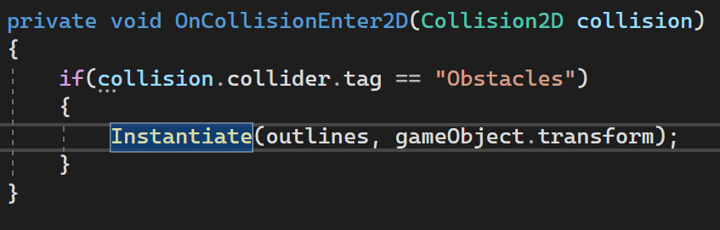

You can also just instantiate it without a parent like this.

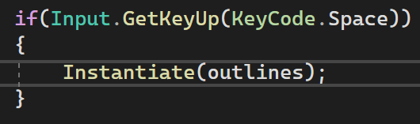

By default the outline will appear on the main camera. If you have multiple cameras and would only like this to appear on certain cameras. You can assign it to a camera by following the steps below.

Create a reference to the one that you want.



Assign it using the function setCamera which takes in a camera type variable and you are done.



You can also change the color of the outlines by going to the prefabs and picking a color in Outlines Color in the script.



Disclaimer : You need to change this color before the outline spawn in.

Default Color : Black

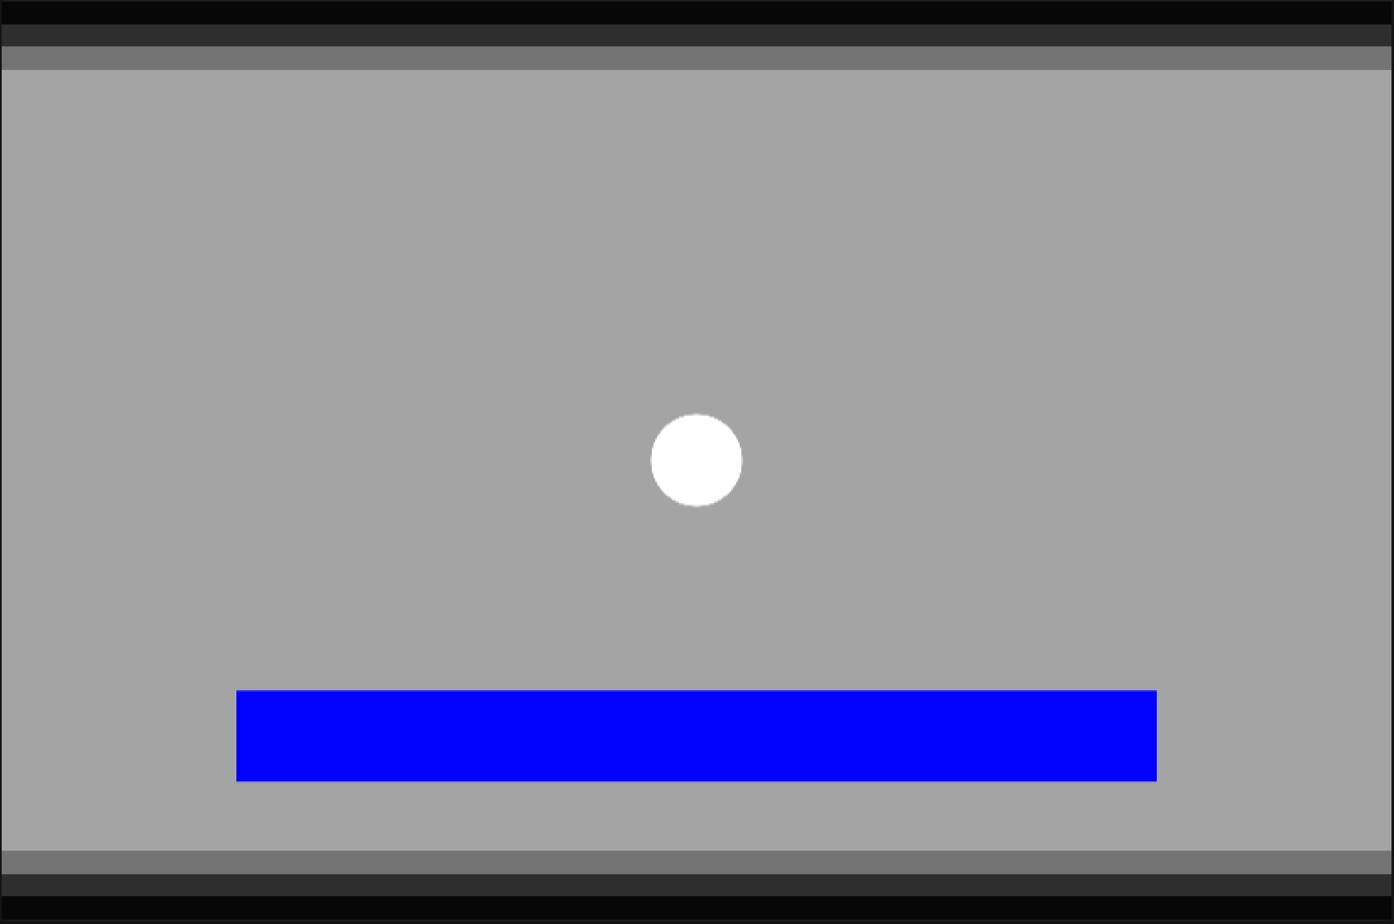

New Color : Red

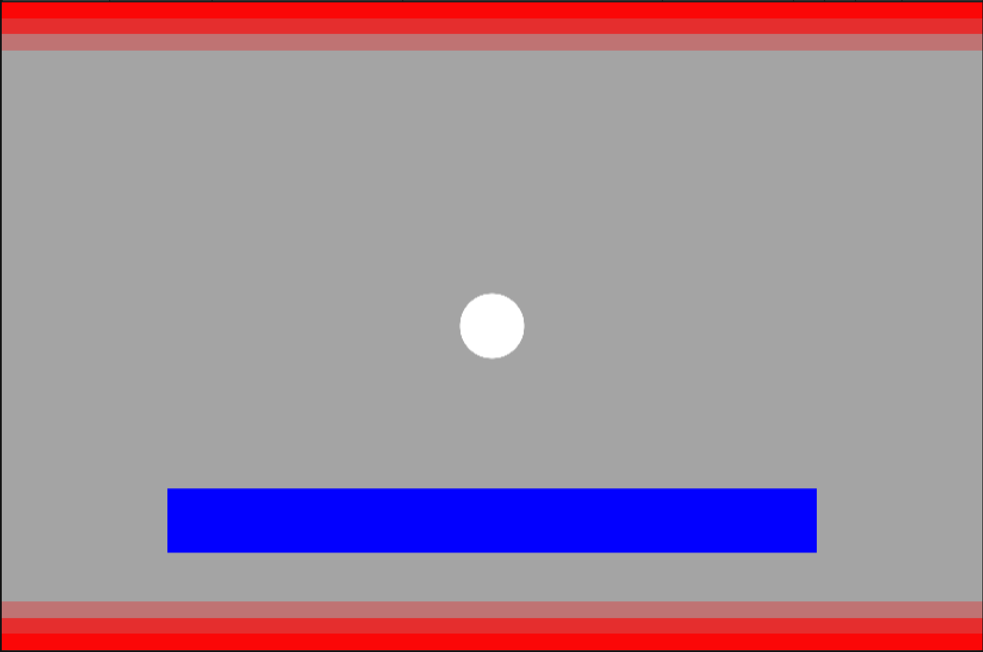

The timer variable is for how long the outlines will stay on screen before going away.

**Camera Effects Script**

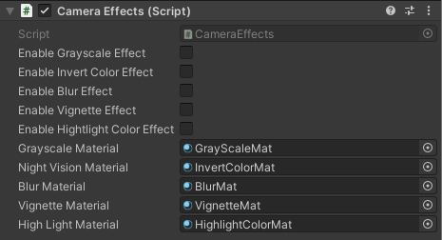

Each of the effects will be explained in detail below and what are the changes you can make to them.

To enable each of these effects , just click on the box of the effect that you want and it will appear on screen. Only 1 effect at a time is allowed at the moment.

Each effects can also be enable from another script , all you need is a reference to the camera effects script and set it to true or false according to your needs like below:





**Materials**

Each material can be adjusted to your needs. To change their behavior , go to the effects material which will be located in the materials folder and you can make changes to them. Changes to each effects will be shown below

**GrayScale Material**

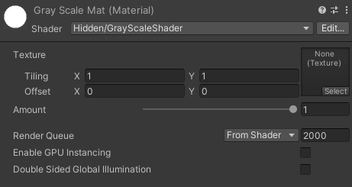

Amount : The closer it is to 1 , the pale the image or scene will appear on screen.

Example:

Amount value of 0.5

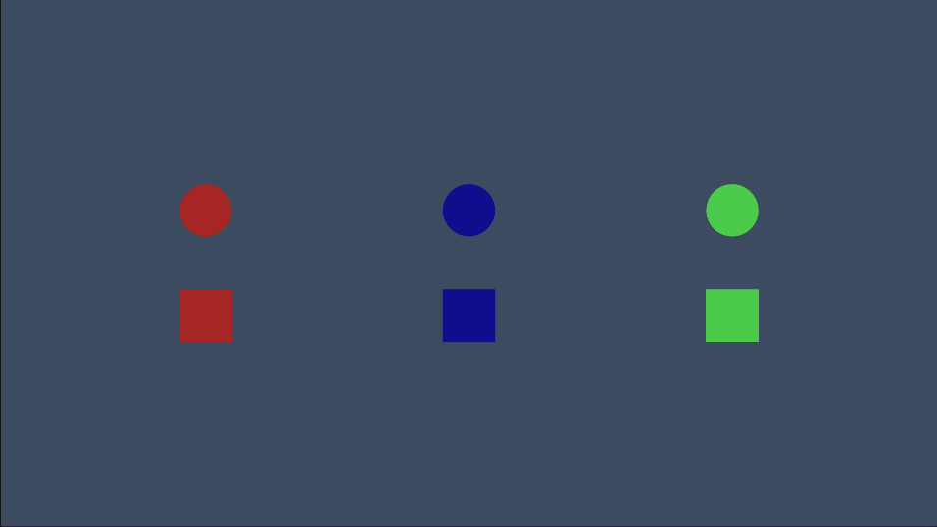

Amount value of 1

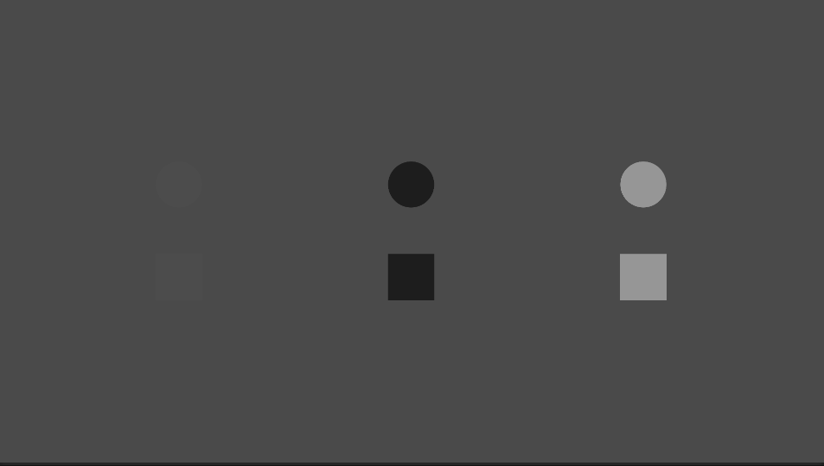

You can see the red is barely visible in this so you might need to alter the amount to suit your needs.

**Invert Color Material** - No custom change are allowed

Invert color take the color of the scene and invert them

Example:

Before

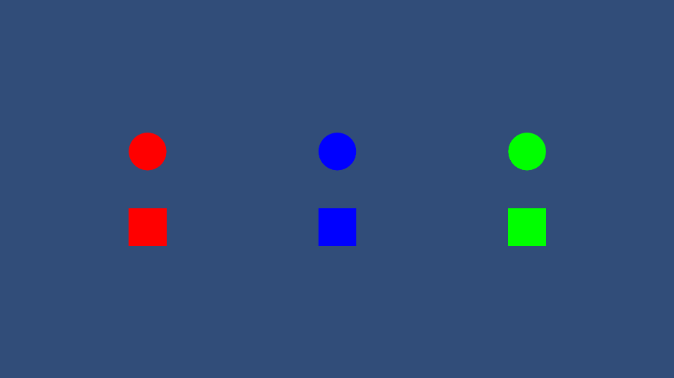

After

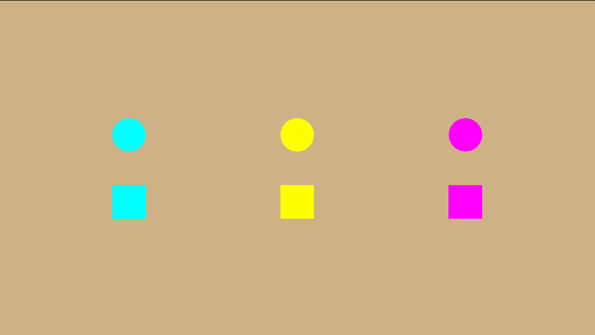

**Blur material**

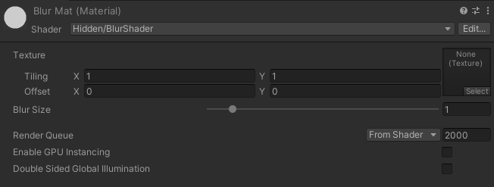

Makes the scene looks blurry

Blur Size : The higher the value , the further apart the alternate images from each other. This can create new effects if the value is really high . The max is 10.

Example

Blur size of 1

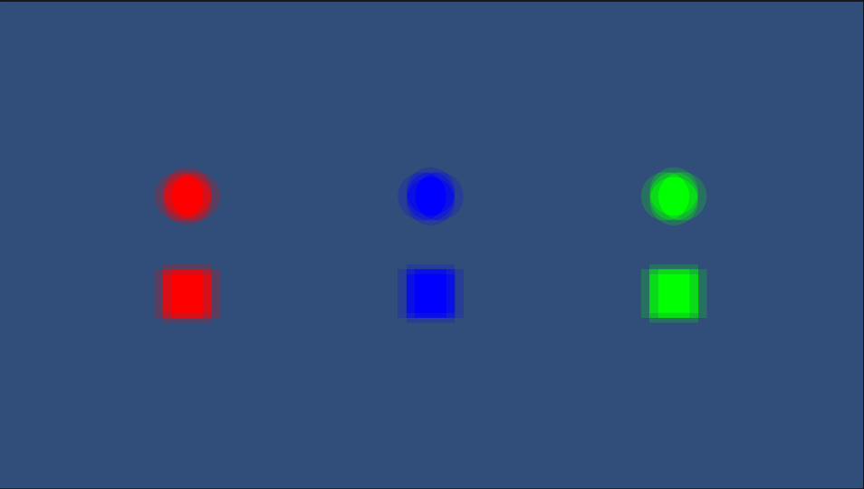

Blur size of 5

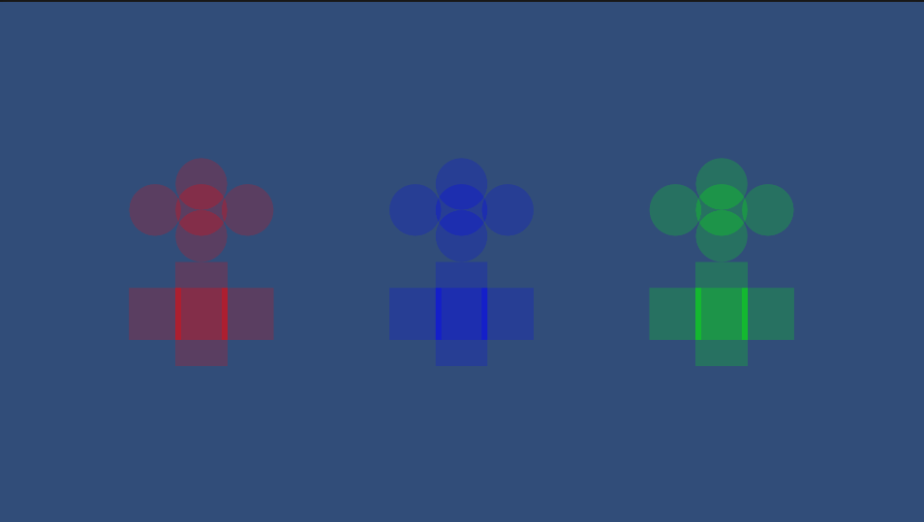

**Vignette material**

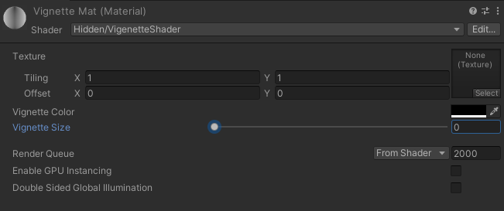

Vignette makes the edges darker (if you pick a dark color) while letting the center part of the screen be transparent. Making it the focus of the scene.

Vignette Color: The color around the edges

Vignette Size: The closer it is to 0 , the more obvious the effect is.

Example:

Black color with the size of 0

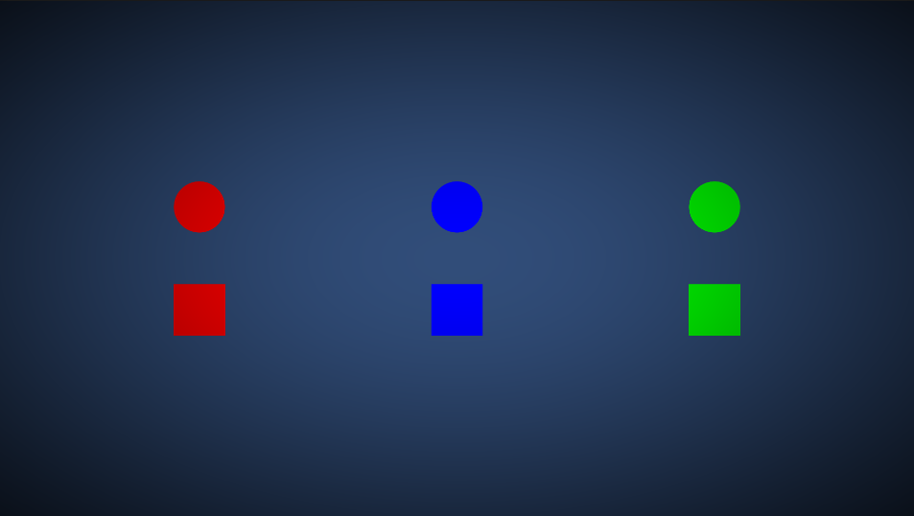

Red color with the size of 0.3

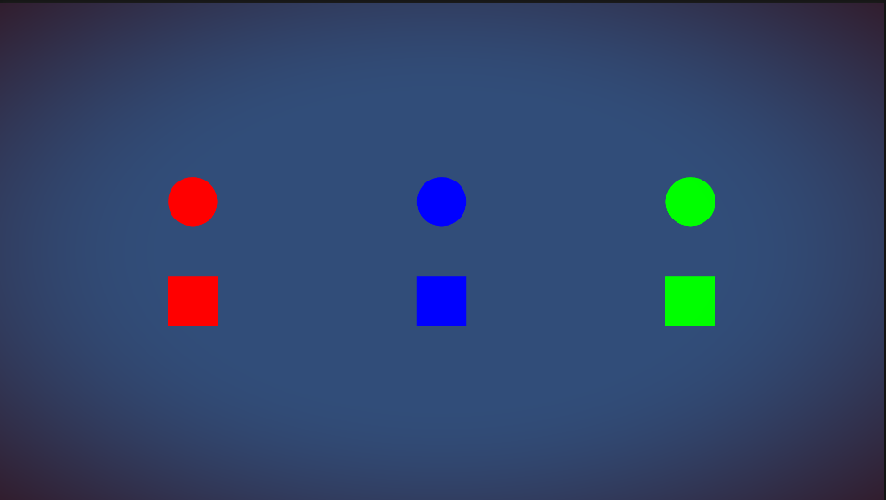

**Highlight Color Material**

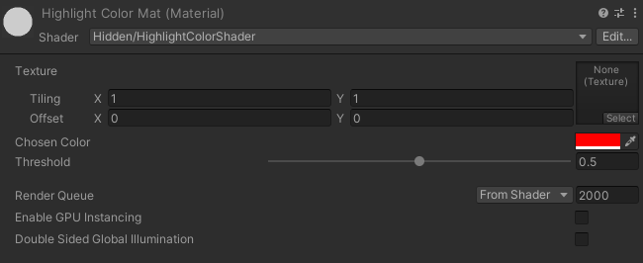

Highlight color makes everything into black and white except for a color of your choice.

Chosen color : Color that will remain the same while everything else is black and white

Threshold : how close the color value must be to your color choice to be considered as not black and white.

Example:

Red color as chosen with threshold of 0.5

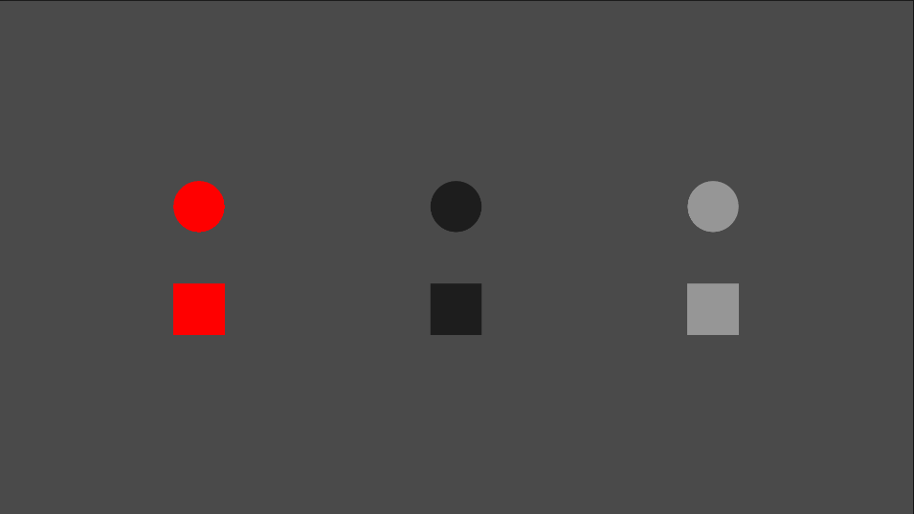

Red as chosen color with threshold of 0.9

